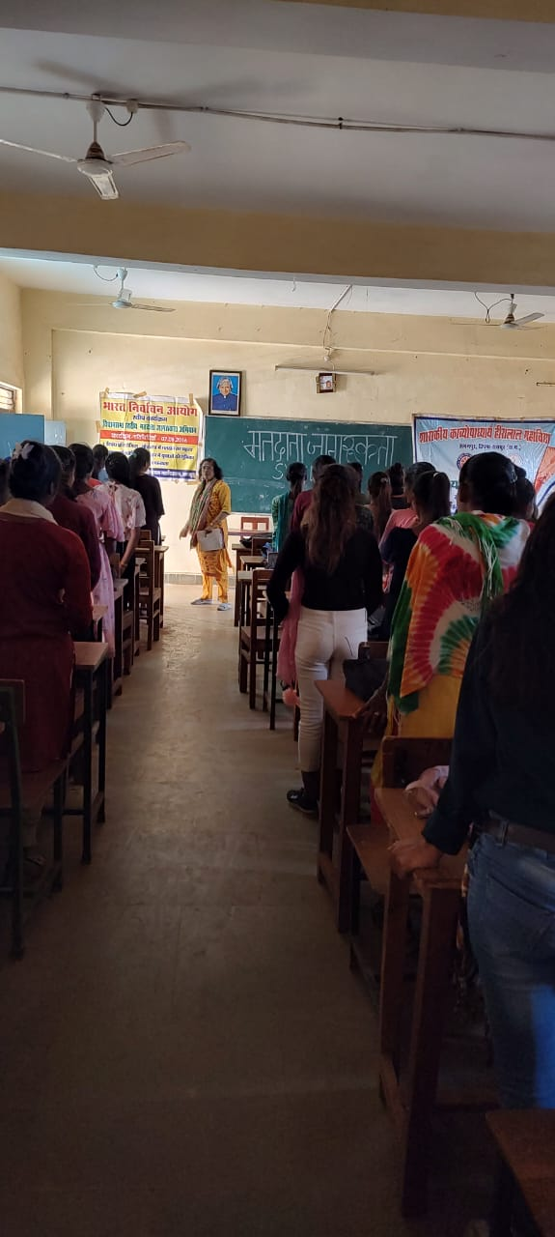
Making Female students aware about importance of voting for nation and society under SWEEP program
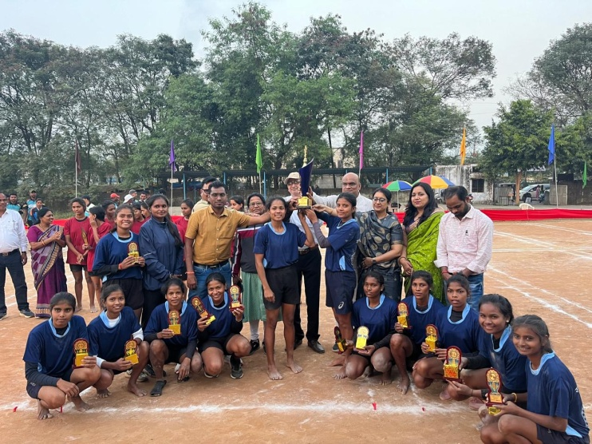
Girl students winning Second level Sector level Kho Kho touranment on 16 Dec 2023

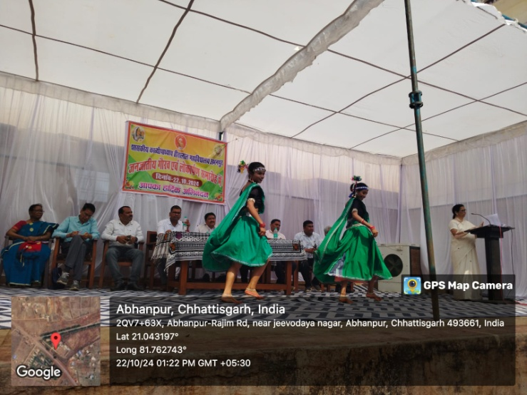
Girl students performing in World Tribe Day

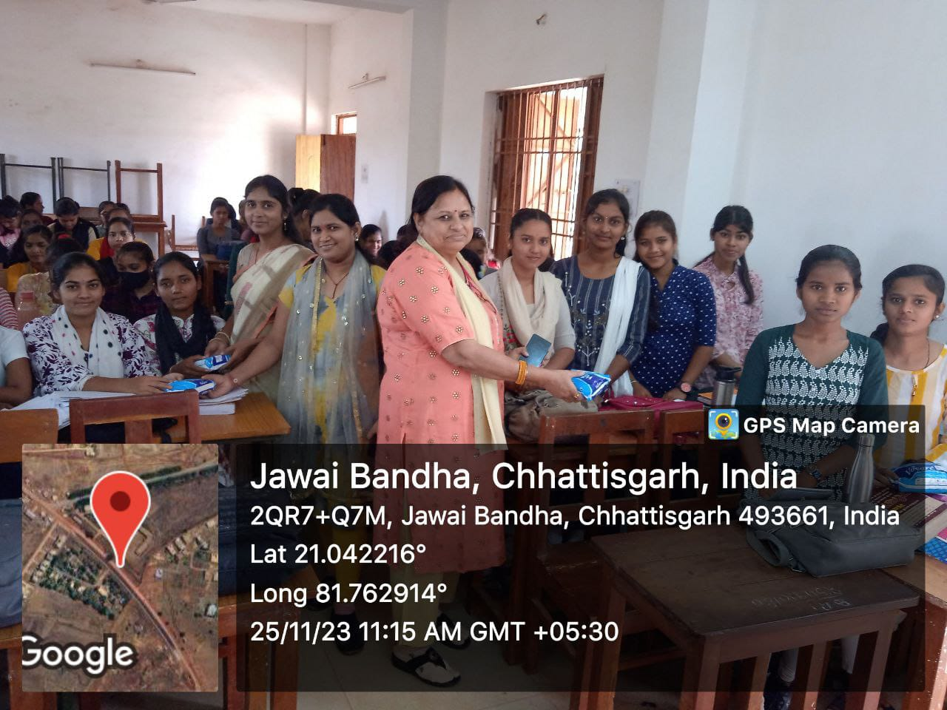
Sanitary pad distribution to the college female students on 25.11.2023
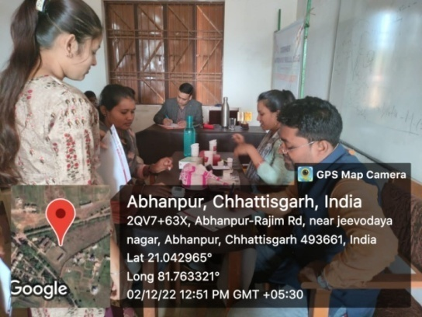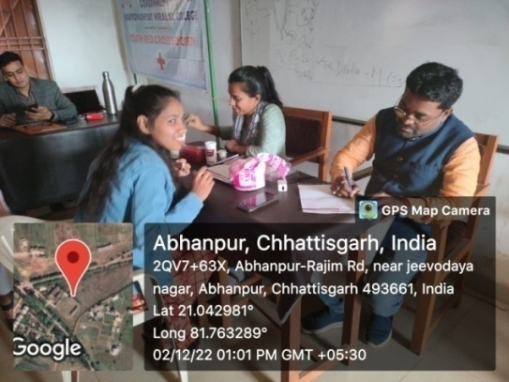
General health checkup camp for girl students
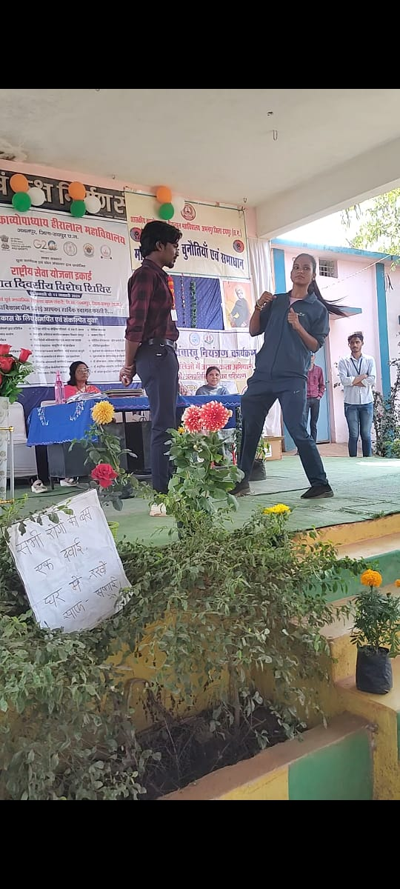

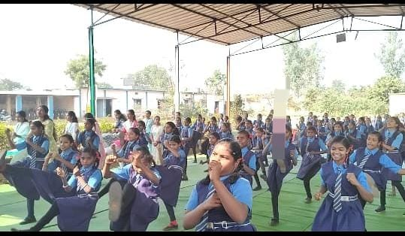
Judo karate training in NSS camp

